***ELECTRONICS FOR INNOVATORS***

***Robotics Class***

* What is a robot?

-A robot is a type of automated machine that can execute specific tasks with little or no human intervention and with speed and precision.

* Application areas of robots.
* **Health care**

-they help in performing operations more precisely e.g. can be used as prosthetic limbs.

* **Industrial use**

-they are used to perform many repetitive and monotonous tasks with precision under guidance and supervision of humans.

* **Military use**

- they can be used as drones to keep surveillance; they can also be used as armed systems to attack the opposing forces.

* **Entertainment**

-they can be used to do stunt work that is very dangerous for humans but looks pretty cool in an action movie.

* **Underwater Exploration**

- they are remote controlled to collect data and images in depths of the ocean.

* Parts of a robot.

1. *Electronics*; Microcontrollers- used to collect the information from various input devices such as sensors and switches.

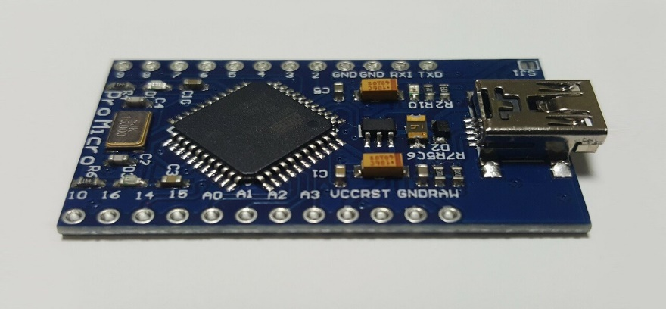

1. *Sensors*; Ultrasonic sensors-they work by **sending out a sound wave at a frequency above the range of human hearing**. The transducer of the sensor acts as a microphone to receive and send the ultrasonic sound. Our ultrasonic sensors, like many others, use a single transducer to send a pulse and to receive the echo.

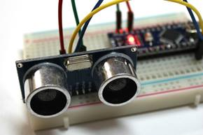

1. *Actuators:* An actuator is a device which causes something to happen. This could be a robot movement, which is often achieved using motors: **An actuator is needed to make the robots wheels turn**. Or the joints of a robot arm to rotate.

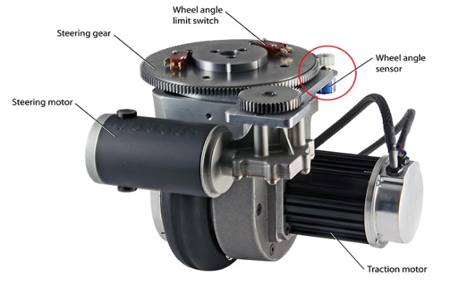

* Introduction to ROS.

-The **Robot Operating System (ROS)** is a set of software libraries and tools that help you build robot applications. From drivers to state-of-the-art algorithms, and with powerful developer tools, ROS has what you need for your next robotics project. And it's all open source.

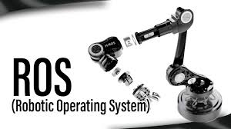

* Designing using CAD.

-The CAD design **allows the designer to see the precise geometric shapes of a robotic product from all angles on the display**; and the software can simulate the reaction of one part against new or existing parts for strength and stress.

* Simulation and testing.

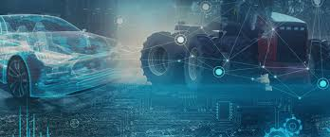

Running tests in a simulated virtual environment enables robot software developers to confirm their applications result with the correct robot behavior. Simulation-based testing can involve: debugging an algorithm during iterative development, testing a subsystem such as localization or object detection, or testing the functionality of the complete system such as navigating from start to goal.

**BLOCK DIAGRAM OF A ROBOT!!!!**

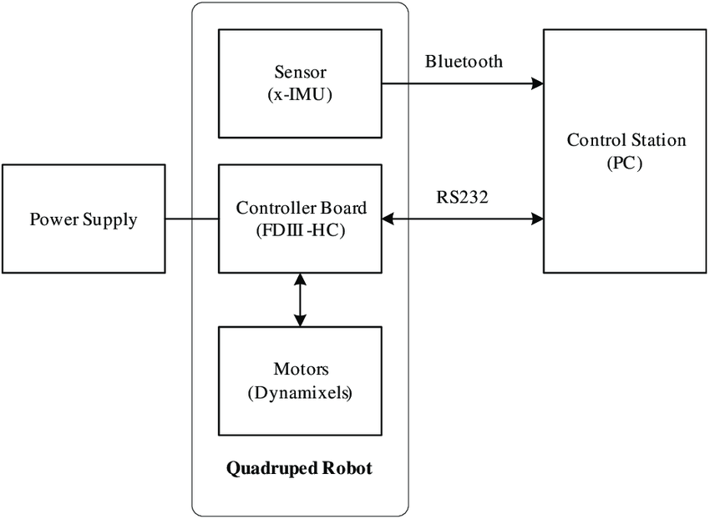

[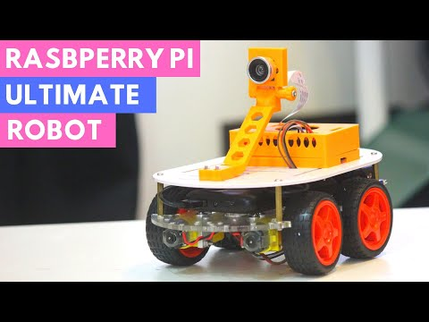](https://www.youtube.com/watch?v=Zdv4cOmOmb8)

***A short video on the set up of a robo-car.***